**China Import Food Enterprise Registration (CIFER)**

**User manual**

***Service économique régional à Pékin***

***Ambassade de France en Chine***

*V1.0 (23 November 2021)*

**This user manual intends to be a technical guide for helping operators to self-register their plant in CIFER, according to the obligations of decree 248 of GACC.**

**Information on this decree 248 are presented elsewhere, when they are provided by GACC.**

**This manual may be updated in the future, according to new developments and information provided by GACC on this procedure of self-registration.**

*NB:*

*Chrome has some problems with creating the account.*

*When filling in the blanks accordingly, you must answer questions with red * marks (compulsory questions).*

**Part I. Create an account**

**Step 1.**

Open the link <https://cifer.singlewindow.cn>

Click “**Create an account**”.

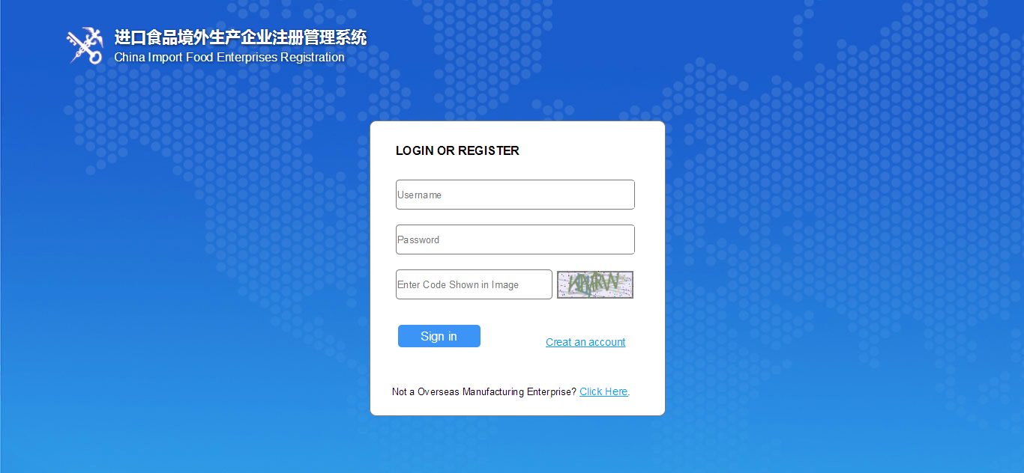

Attention:

* Username: 6-18 letters, or a combination of letters and numbers;
* Password: Any combination of 8-16 uppercase and lowercase letters, numbers and symbols or more;
* Approval number (obligatory): may be the sanitary number given by the national competent authorities or SIRET number (for French companies).

**Step 2.**

Choose “EN” version here and fill the blanks with necessary information. Fill in the blanks with red star * on the left and “located country (region) register number”.

For “located country/region”, choose “FRA” which means France (see below).

Please make sure to fill you SIRET number in “Located country (region) register number”.

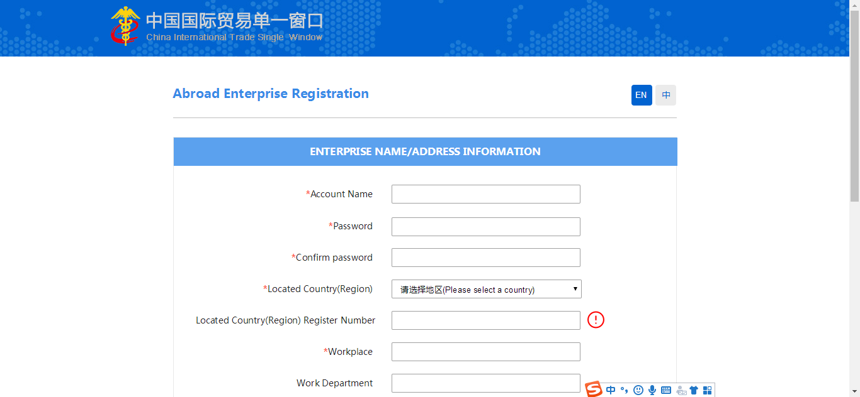

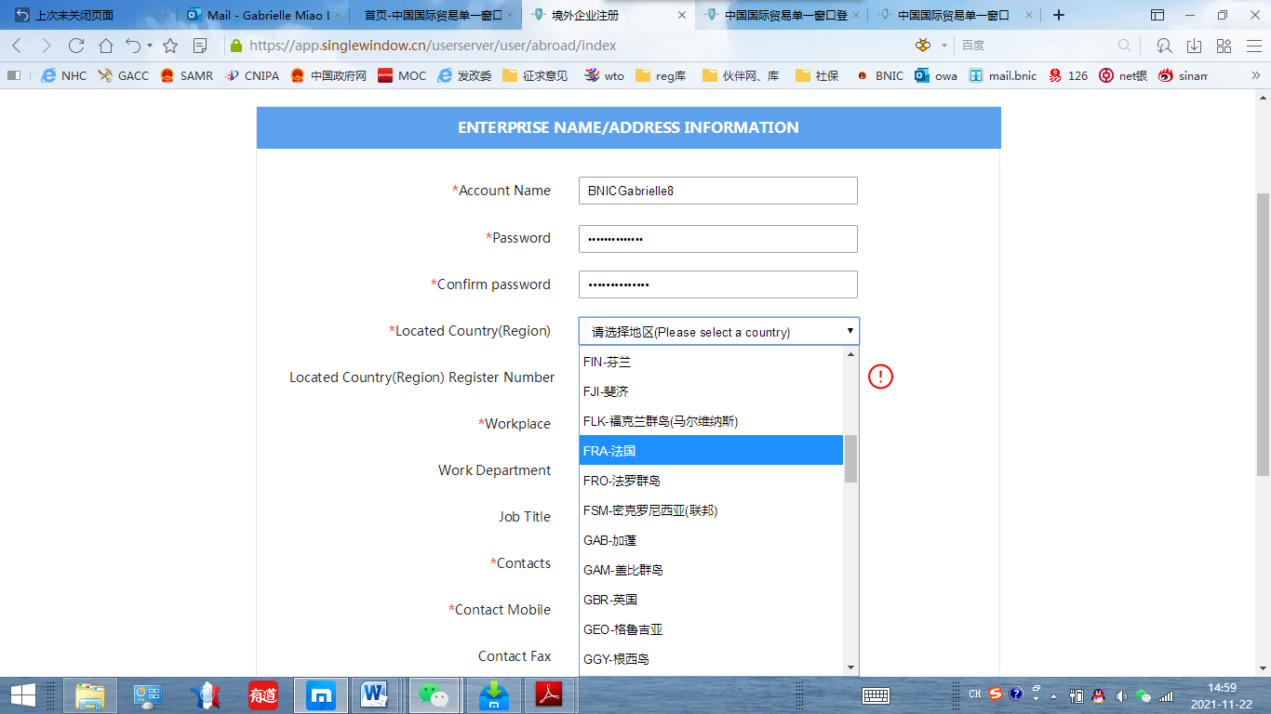

**Step 3.**

When finishing filling the form, roll the page down then you can see the picture below.

Click the button “**Register now**”.

You can then create an account.

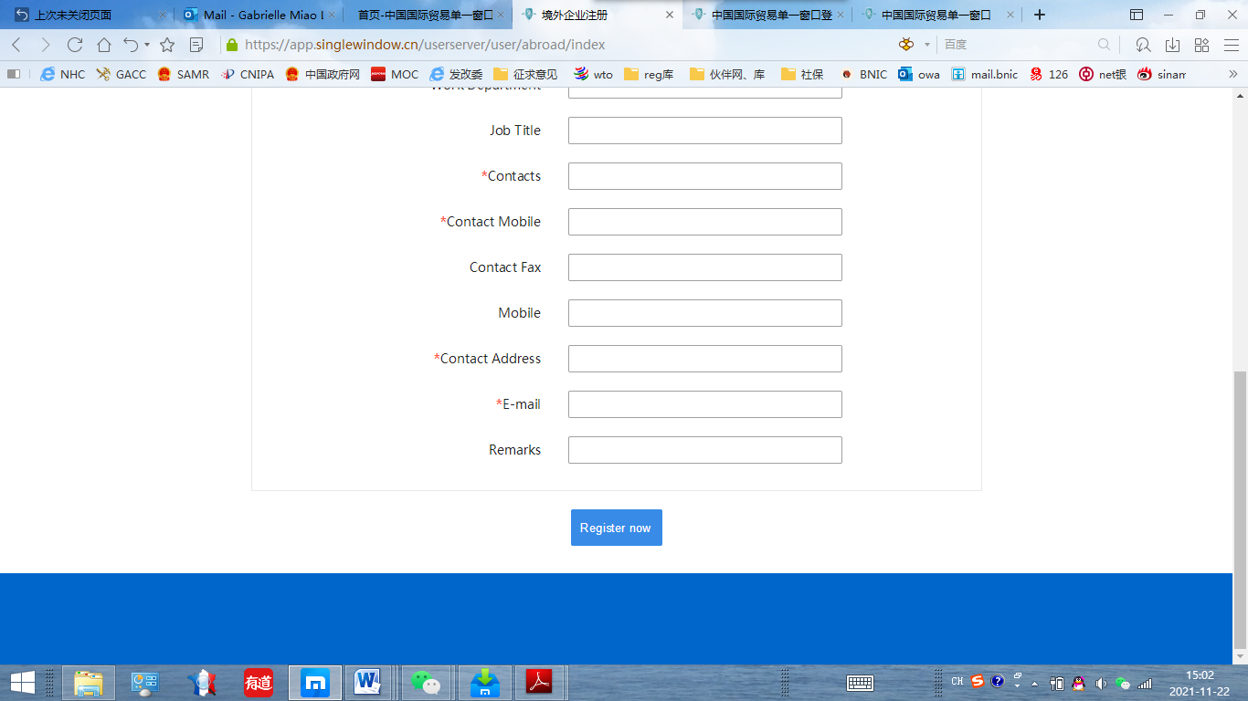

The picture below indicates that you have successfully completed the creation of account.

Click **Log in** to start.

**Creation of account completed**

**Log in**

**Part II Preparation for the registration following 248 for overseas manufactures**

**Step 4.**

When already having an account, please login with the link <https://cifer.singlewindow.cn>

Enter your user name, password of your account, then insert the “verification code” showed in the frame on the right (see the yellow circle). It may not be quite clear. If you can’t recognize it, please click the picture then it will refresh to create a new one.

When you fill all the information, please click “Sign in” to log in.

**Step 5.**

The first page of the system is shown below. You may use auto-translation to translate the page in English or French.

Otherwise you may see:

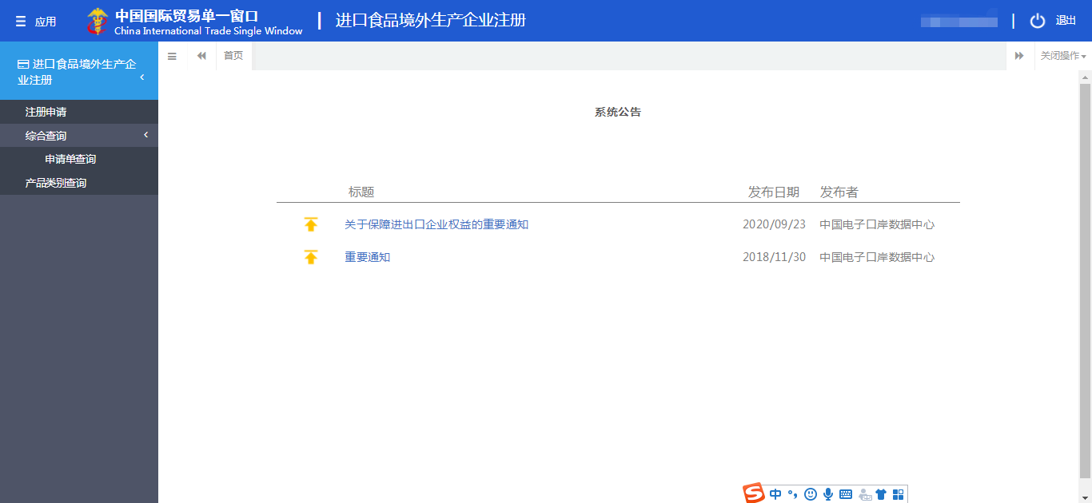

Registration application

Comprehensive inquiry

Application inquiry

Products categories inquiry

* Registration application: create a new application;
* Comprehensive inquiry: just a title;
* Application inquiry searching: check your existing application;
* Products categories inquiry: check the HS code of your products.

**Step 6.**

Click the index circle “Registration application” on the left. (red circle).



**Step 7.**

1. When you see the page below, please use auto-translation of webpage to identify the category of your product, or refer to a detailed translation later in this manual;
2. You can roll down the page to find more categories;
3. Click the blue word indicating your category;
4. Click the relevant sub-category to choose the specific category of your product.

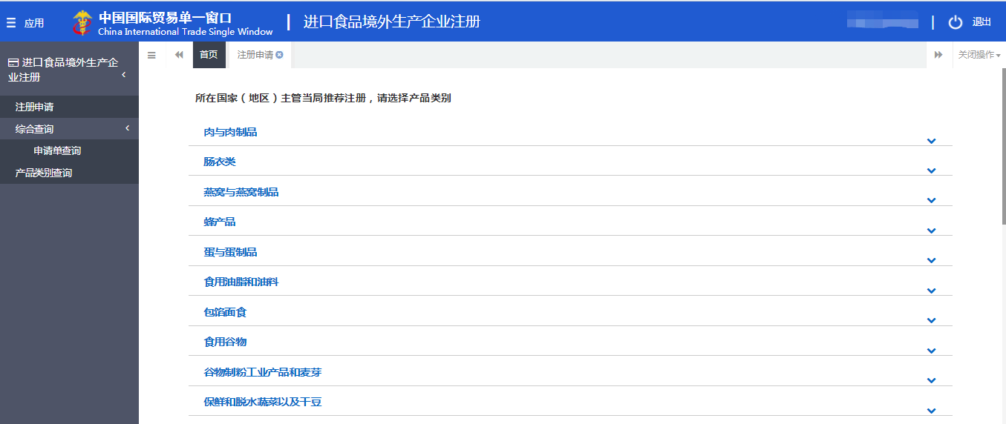

Hereunder, an example of how to choose a distilled spirit category has been done for you.

Example:

Roll down the page and find the category as “**酒类**” (alcoholic beverages), then click it.

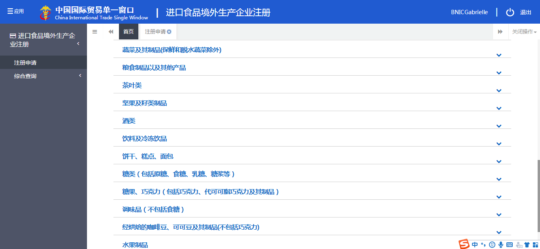

Roll down the page until it’s shown like this

After clicking, you may see a sub-category appearing on the page:

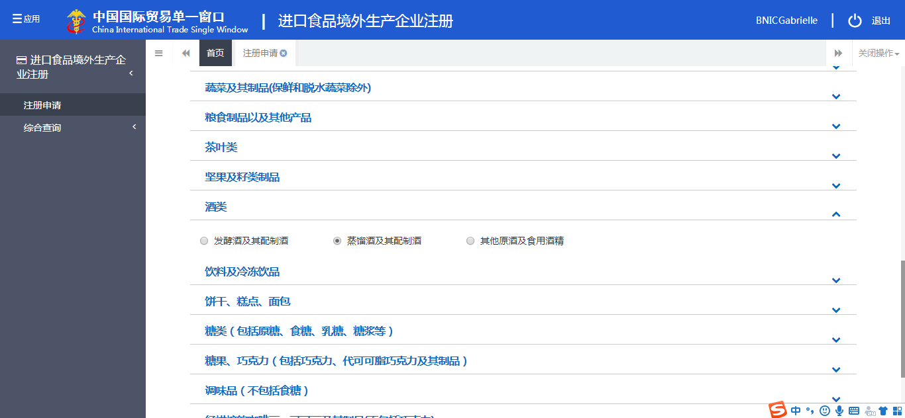

Choose the second one in the middle which is distilled spirit and its integrated alcoholic beverages (red circle above).

***Detailed translation of different categories concerning your products.***

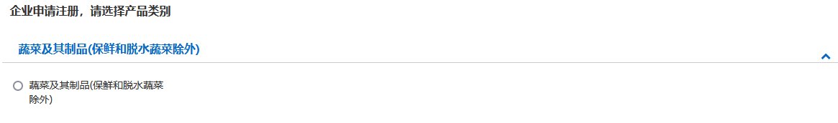

**Registration demand for establishment, please select product category**

**Vegetable and vegetable product (except fresh and dehydrated vegetables)**

°Vegetable and vegetable product (except fresh and dehydrated vegetables)



**Grain and other related products**

°Grain and other related products



**Tea**

°Tea



**Nuts and seed products**

°Nuts and seed products



**Liquor** (from left to right)

°Fermented wine & its blended wine

°Distilled wine & its blended wine

°Other original wine and edible alcohol

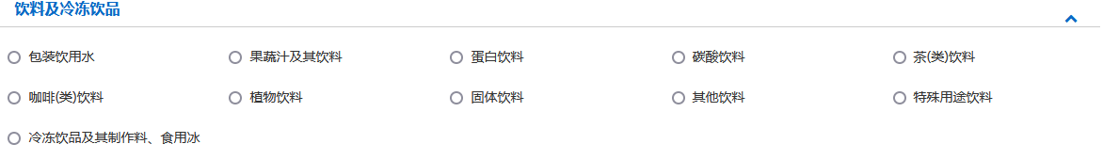

**Beverages and frozen drinks** (From left to right)

°Packaged drinking water

°Fruits and vegetables juices and related beverages

°Protein drink

°Carbonated drinks

°Tea (type) beverage

°Coffee (type) beverage

°Plant drink

°Solid drink

°Other drinks

°Special purpose beverages

°Frozen drinks and their preparation materials, edible ice



**Biscuit Pastry Bread**

°Biscuit Pastry Bread



Sugars (including raw sugar, table sugar, lactose, syrup, etc.)

°Raw sugar °Table sugar °lactose °Syrup °Other sugars



**Candy, chocolate (including chocolate, cocoa butter substitute chocolate and its products)**

°Candies °Chocolate °Other sweets, chocolate



**Condiments (not including sugar)**

°Cooking salt °Soy sauce °Vinegar °MSG °Other seasonings (not including sugar)



**Roasted coffee beans, cocoa beans and their products (excluding chocolate)**

(From left to right)

°Roasted coffee beans and their products (excluding chocolate)

°Baked cocoa beans and their products (excluding chocolate)



**Fruit products**

°Jam fruit °Powder °Canned fruit

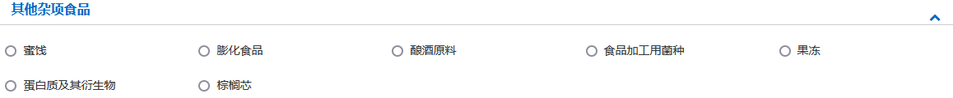

**Other miscellaneous of food**

(From left to right)

°Candied fruit

°Puffed food

°Brewing ingredients

°Strains for food processing

°Jelly

°Protein and its derivatives

°Palm hearts



**TCM**

TCM

**Step 8.**

You are then directed to this step where you shall provide basic information concerning your establishment:

* On the left side, make sure you are on the *Registration application* section;
* On the top of this page, make sure you are on *Your product category +* section. Here the example of spirits category has been done for you.

Then:

1. **Fill in the blanks with red star. You can choose to Save for now** or **Delete** the information provided;

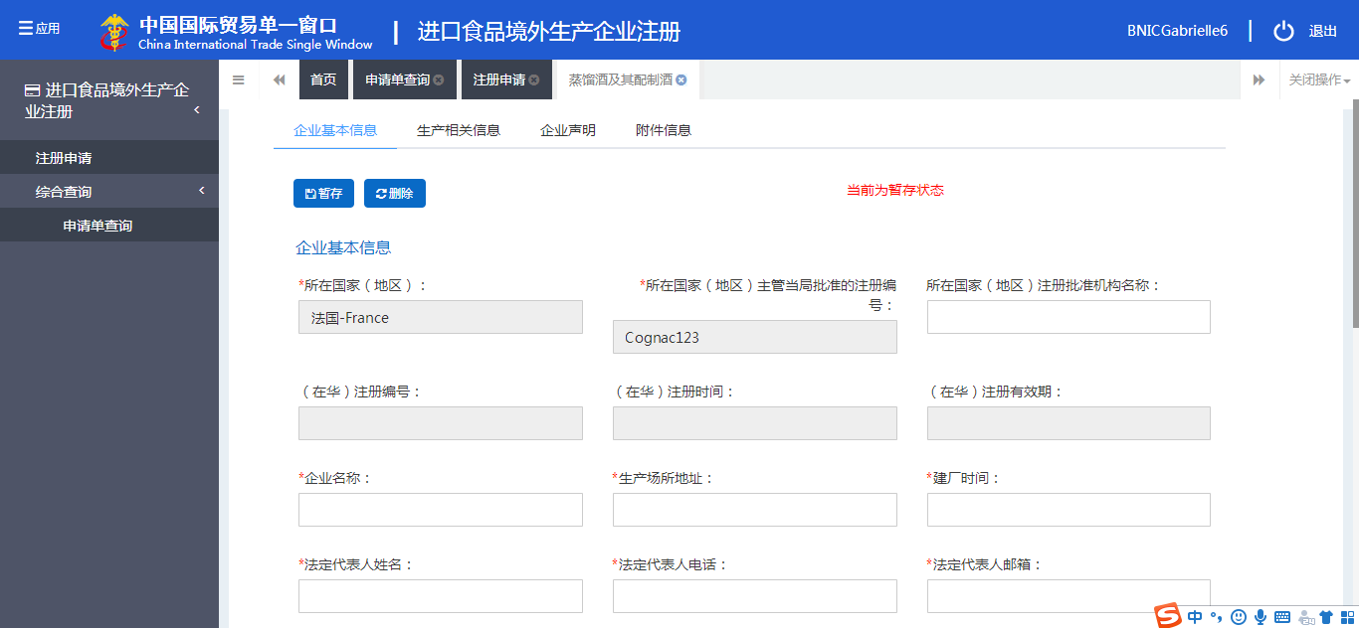

Country/Region

Registration application

Creation time

Company address

Company name

Approval numbernumber

**Save for now ; Delete**

Legal representative phone number

Local authority name

Legal representative name

Legal representative email

Tip: Here you can see the information of *Country/Region* and *Approval number* are already inserted automatically according to what you have filled in when creating the account. The blanks in grey are not writable. Please fill other information. **For “Creation time”, it’s only dated back to 1900-01-01.**

1. Roll down the page to fill in more blanks;
2. Click **Upload** (yellow circle) to upload company ID file.

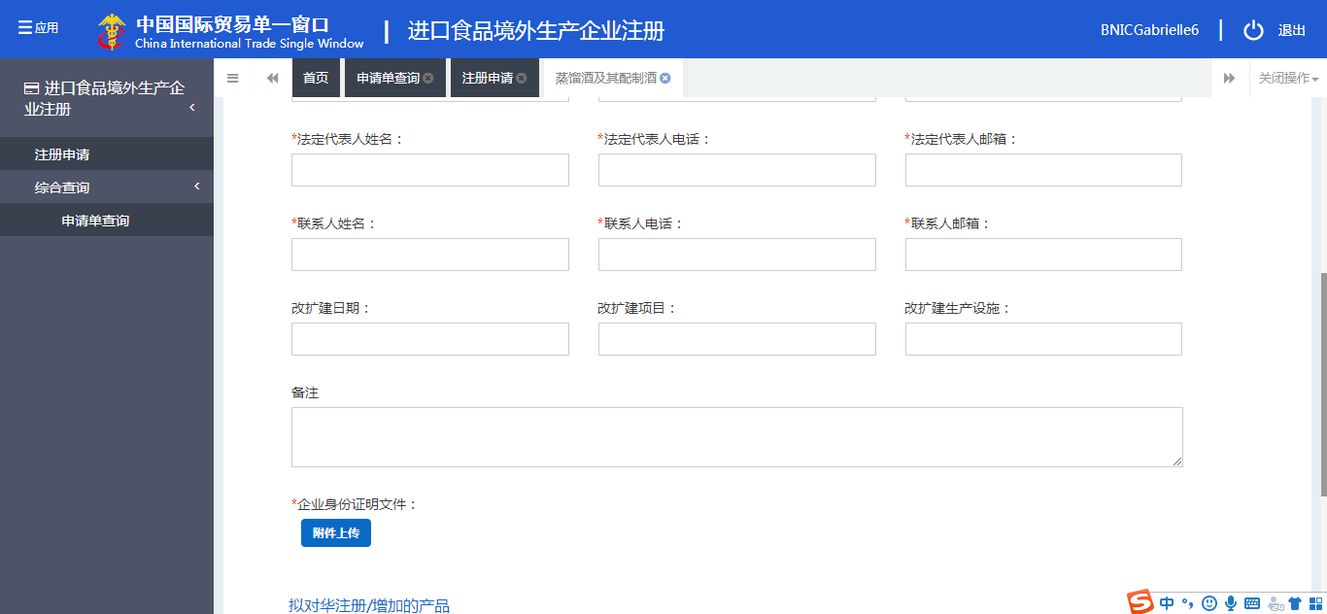

Notes

Contact person email

Contact person phone number

Contact person name

Company ID document

**（Upload button）**

**Step 9.**

In this step, you need upload your company ID file.

1. Click **+ Add** to add the file;
2. Then click **Upload/Save** to proceed.

Tip: *Operation* has nothing to do with you in this step. You can ignore it.

Example:

the file whose type is “production permission granted by the competent authority of the country where is situated your company” need uploading.

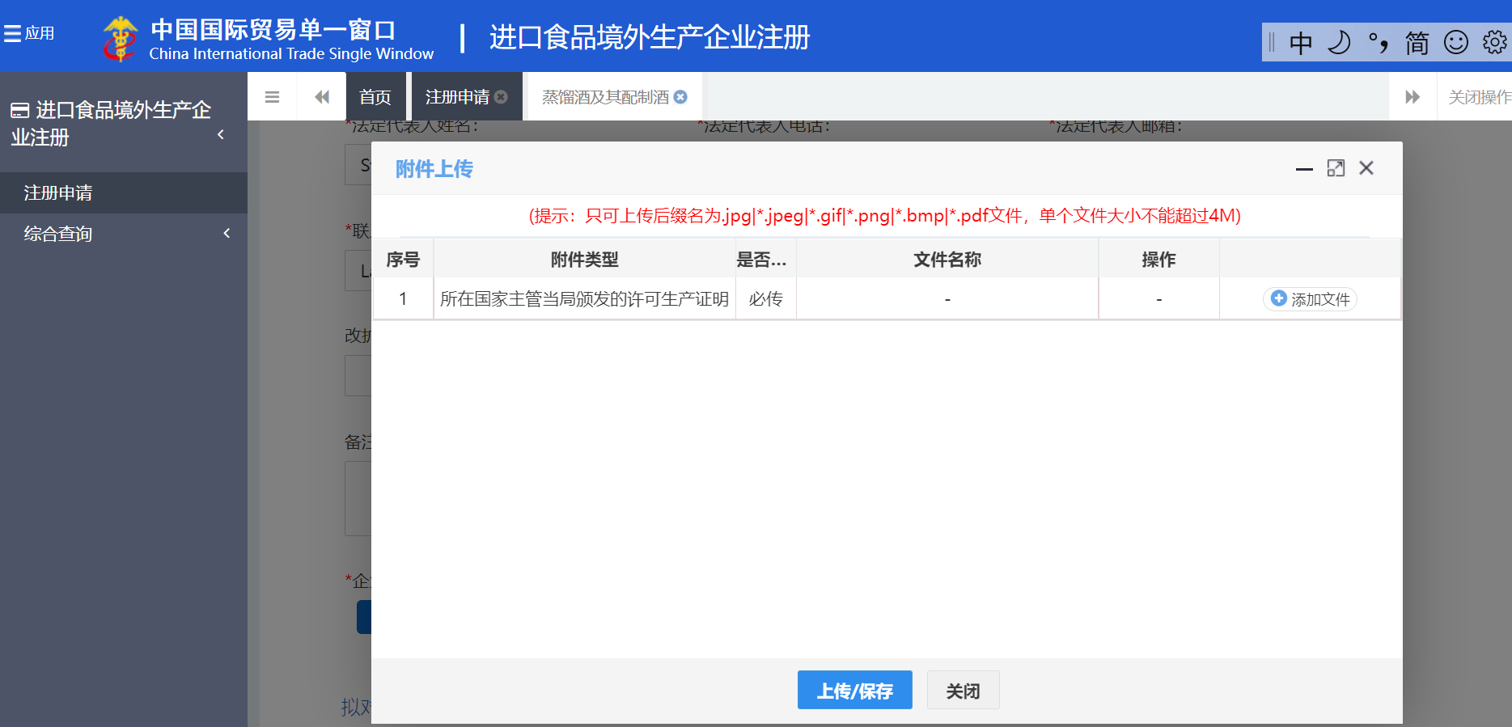

Registration application

Registration application

1, production permission granted by the authority of country where is situated your company, compulsory, -, -,

N°, Attached file type, If it is compulsory to upload, File name, Operation, **+ Add**

**Upload/Save Close**

Only accept documents in jpg,jpeg,gif, png,bmp,pdf formats, smaller than 4M.

Your product category +

**Upload file**

Translation of example:

|  |  |  |  |  |
| --- | --- | --- | --- | --- |
| N° | Attached file type | If it is compulsory to upload | File name | Operation |
| 1 | Production permission granted by the authority of country where is situated your company | Yes | _ | Upload |

**Step 10.**

This is what you will see after you upload the file.

You will see in the line below the file which you have uploaded. Then:

1. You can choose to **delete or download** it;
2. You can continue to click **+ Add** to upload other files;
3. Click **Upload/Save** to proceed.

Example:

The file whose type is “production permission granted by the competent authority of the country where is situated your company” has been uploaded.

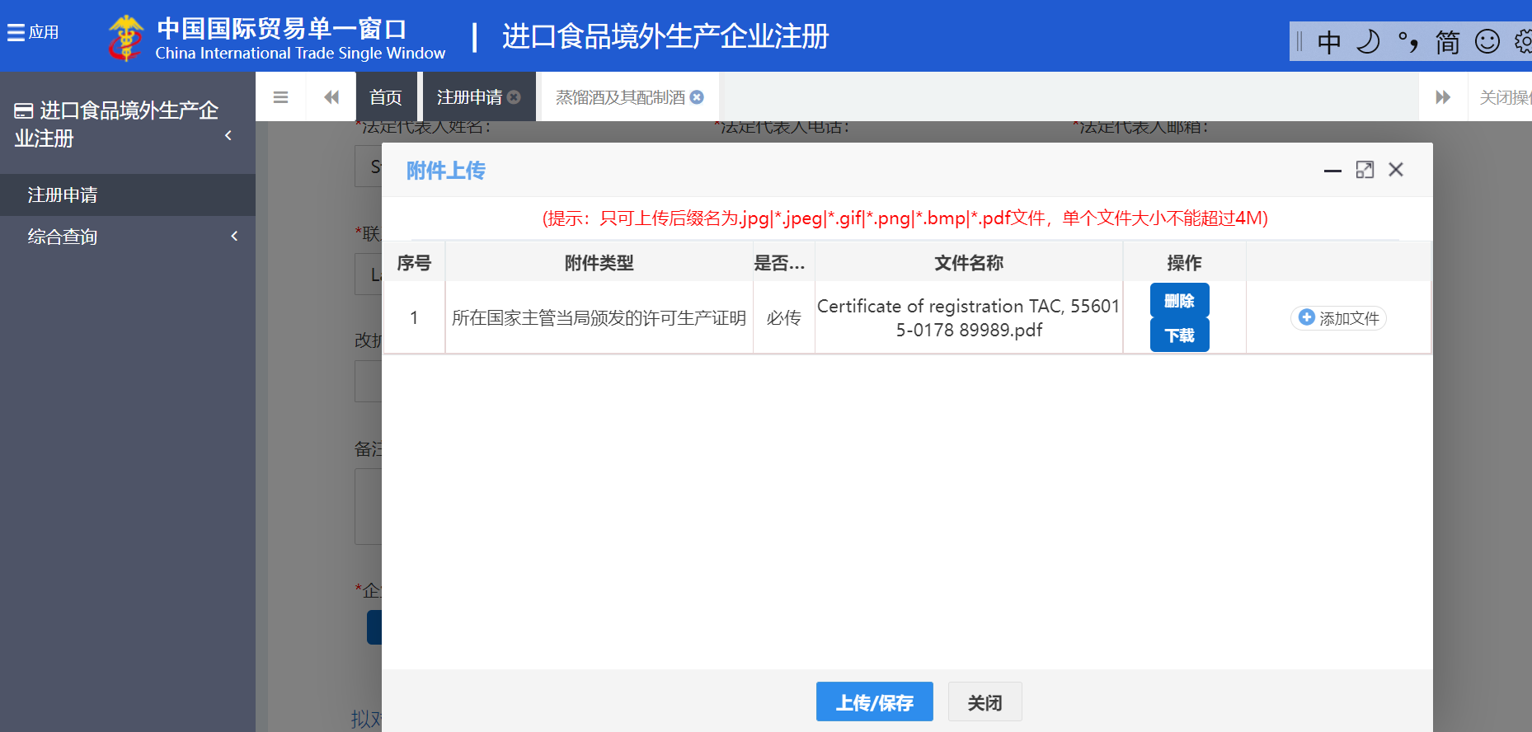

**Upload**

Only accept files in jpg,jpeg,gif, png,bmp,pdf formats, smaller than 4M.

N°, Attached file type, If it is compulsory to upload, File name, **Delete + Add**

**Download**

**Upload/Save Close**

Translation of example:

|  |  |  |  |  |
| --- | --- | --- | --- | --- |
| N° | Attached file type | If it is compulsory to upload | File name | Operation |
| 1 | Production permission granted by the authority of country where is situated your company | Yes | Certification of registration TAC, 556015-0178 89989.pdf | Delete Upload  Download |

**Step 11.**

Then the website will automatically direct you to the page below:

In this step, you need to provide information concerning products to be exported to China.

Click **+ Add 1** to fill in information concerning Products to be registered/added to China.

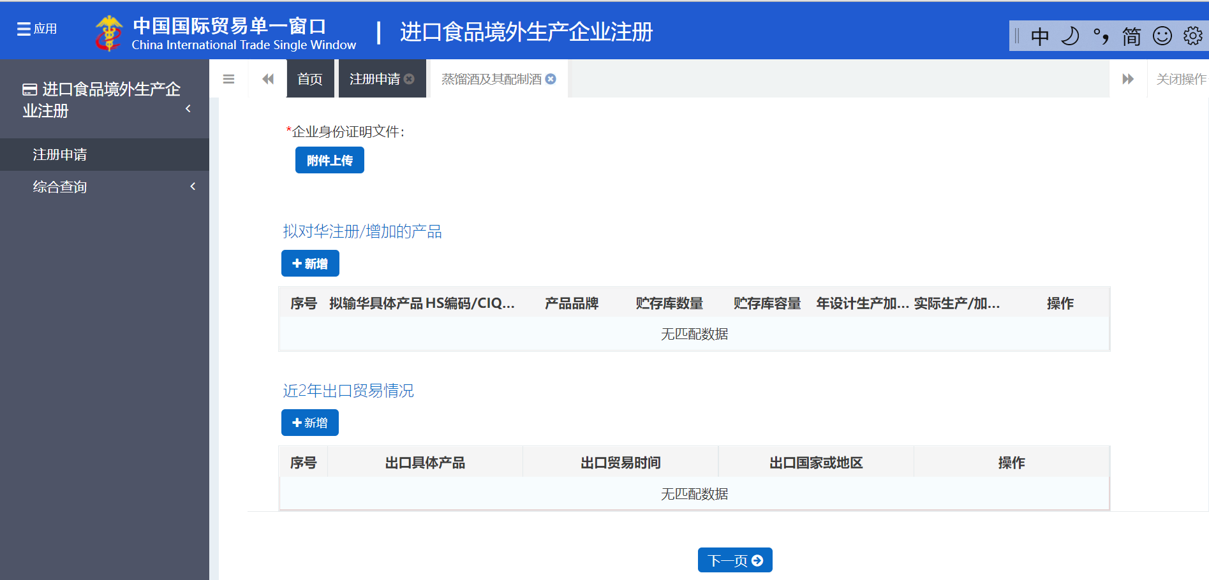

N°, Product to be exported to China, HS code, Brand, Number of storage warehouse, Storage capacity, Annual designed productivity, Actual annual production/processing capacity, Operation

Products to be registered/added to China

**+ Add 1**

N° Exported product Export time Destination (country/region) Operation

**Next Page**

Export trade situation in last 2 years

**+ Add 2**

Company identity certificate:

**+ Upload**

**Step 12.**

Once you click + **Add 1,** you will see the page below, by which you are able to provide concerning products to be registered or added to China.

Attention:

When you choose “nothing” in *Production type* section, you will see the page below.

Only those who choose “storage” as their *Production type* need fill in the two blanks related to storage situation.

1. You need to fill in the blanks accordingly;

Tip: you cannot enter the HS/CIQ code. You can only choose the code by clicking the button.

1. You need to upload relevant files by clicking **+ Upload**;
2. Click **Save** to proceed.

Example: The file to be uploaded are photos of products to be exported to China.

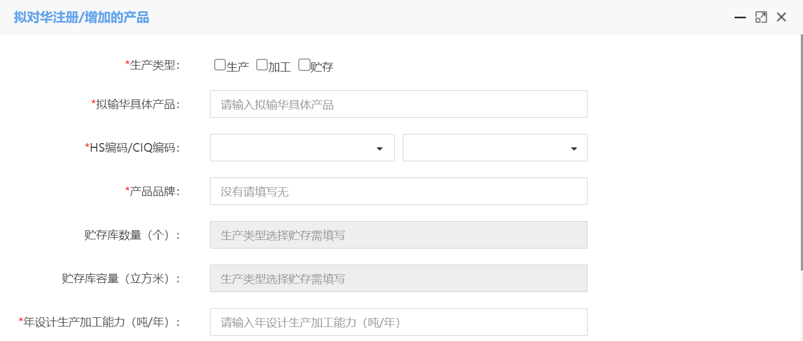

**Products to be registered/added to China**

Storage capacity (cubic meters). Only applicant choosing storage as his *Production type* need fill in this blank

Number of storage warehouse. Only applicant choosing storage as his *Production type* need fill in this blank

Production type : □Produce □Processing □Storage

Annual designed productivity (ton/year)

Specific product to be exported to China

Product brand enter No if there isn’t

HS Code/CIQ Code

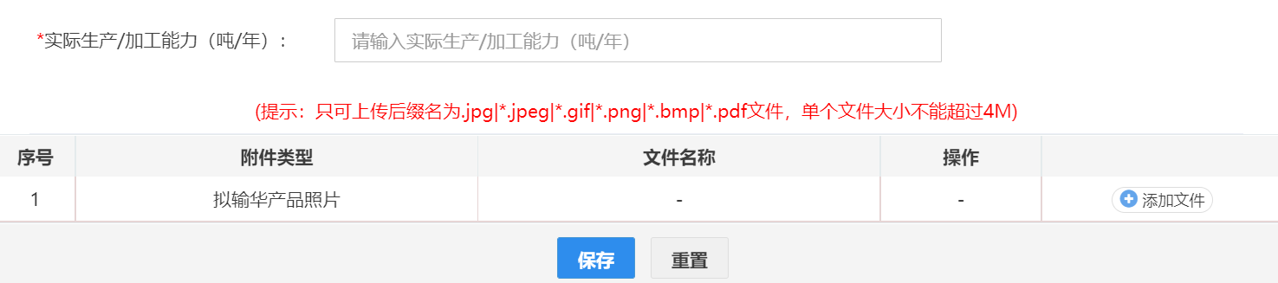

N° Attached file type File name Operation **+ Upload**

**Save Reset**

Only accept files in jpg,jpeg,gif, png,bmp,pdf formats, smaller than 4M

Actual annual production/processing capacity (ton/year)

When you have chosen *Production* in the *Production* *type* section, you will see the page below. However, as mentioned above, *Number of storage warehouse* and *Storage capacity* sections would become grey and hence could not be filled in. This is the only difference. You could follow the above procedure to proceed.

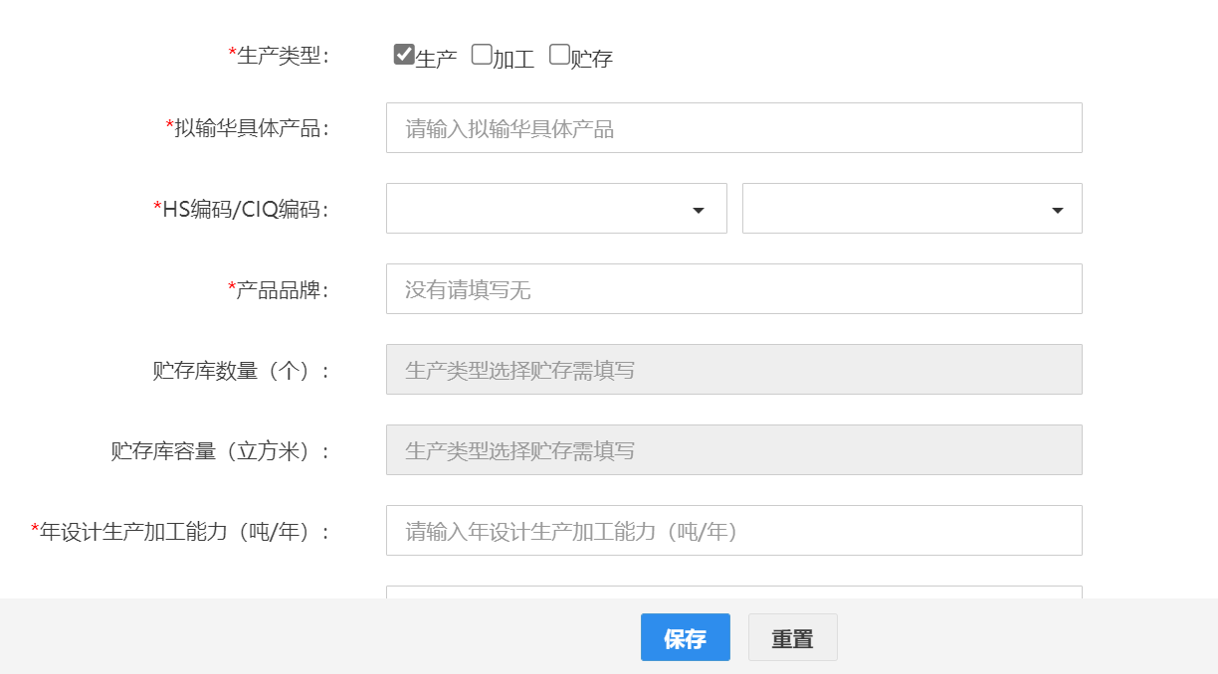

HS Code/CIQ Code

Product brand enter No if there isn’t

Production type : □Produce □Processing □Storage

Storage capacity (cubic meters). Only applicant choosing storage as his *Production type* need fill in this blank.

Number of storage warehouse. Only applicant choosing storage as his *Production type* need fill in this blank.

**Save Reset**

Annual designed productivity (ton/year)

Specific product to be exported to China

Once you click Save, you can see the page below, indicating that you have finished filling information concerning products to be exported to China.

Then:

1. You can see in 1 and 2 lines the product information which you have provided;
2. You can choose to delete or edit them;
3. You can choose to click **+ Add 2** to provide information concerning Export trade situation in last 2 years. (This section might be optional for your company);
4. If you don’t need or want to provide export situation within last 2 years, click **Next page**. Then turn to Step 14.

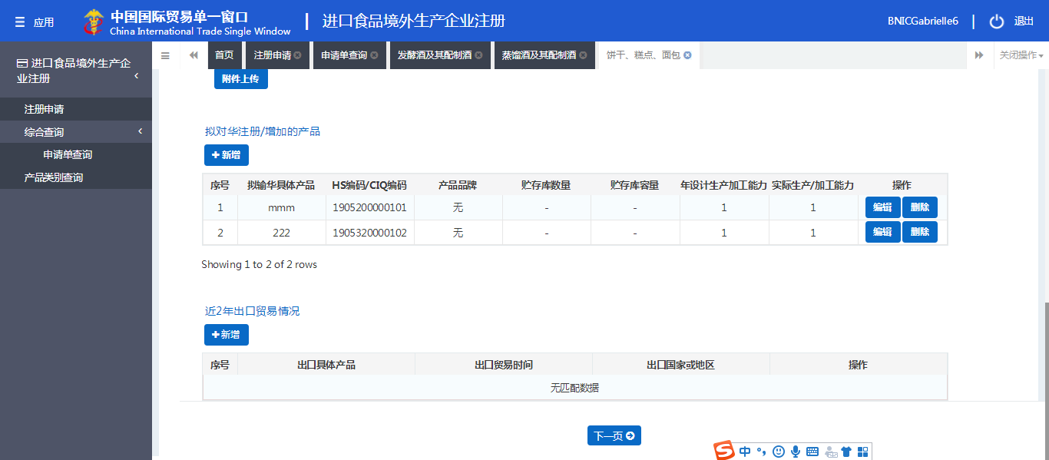

**Next Page**

Export trade situation in last 2 years

**+ Add 2**

**Edit Delete**

N°, Product to be exported to China, HS code, Brand, Number of storage warehouse, Storage capacity, Annual designed productivity, Actual annual production/processing capacity, Operation

**Step 13.**

This page collects the information concerning export trade situation in last 2 years.

1. You need choose the *Specific exported product* and *Destination (country/region)* by clicking the small button , then fill in the export trade time;
2. Click **Save** to proceed.

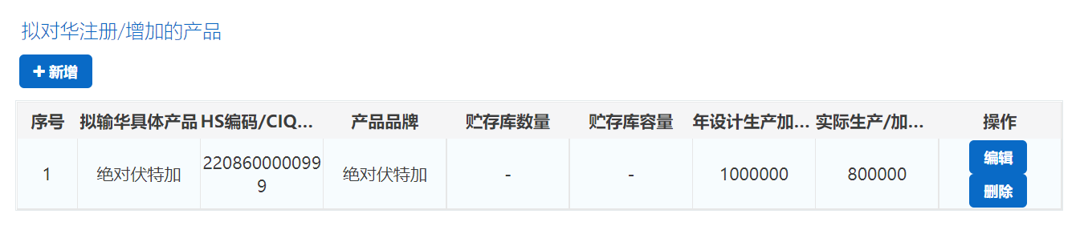

N°, Product to be exported, HS/CIQ code, Brand, Number of storage warehouse, Storage capacity, Annual designed productivity, Actual annual production/processing capacity, Operation

**+Add**

**Edit**

**Delete Delete**

Products to be registered/added to China

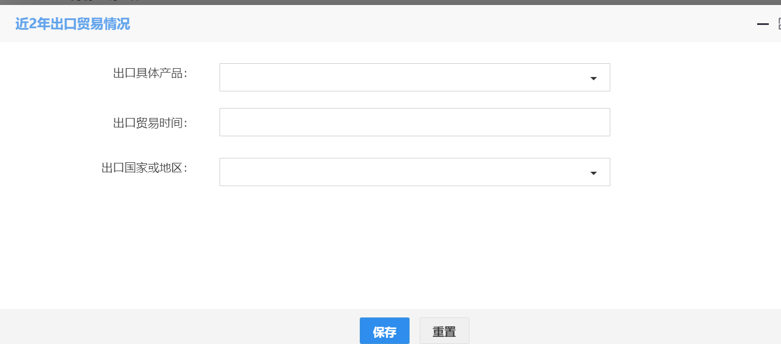

Specific exported product

(You must provide this information)

Export trade time

Destination (country/region)

**Save Reset**

**Export trade situation in last 2 years**

Example translation:

|  |  |  |  |  |  |  |  |  |
| --- | --- | --- | --- | --- | --- | --- | --- | --- |
| N° | Product to be exported | HS/CIQ code | Brand | Number of storage warehouse | Storage capacity | Annual designed productivity | Actual annual production/processing capacity | Operation |
| 1 | Absolut vodka | 2208600000999 | Absolut vodka | _ | _ | 1000000 | 800000 | Edit Delete |

**Step 14.**

Now you need provide information concerning “Production related information” (Step 14-18).

It has 3 main sections (from top to bottom):

1. Raw material/ingredients information;
2. Affiliated company information;
3. Processing information, including: water for production use, processing techniques and HR information.

You click **Add 1** and **Add 2** to provide information related to section a and b, then roll down the page to fill in blanks concerning water for production and processing use (starting section c).

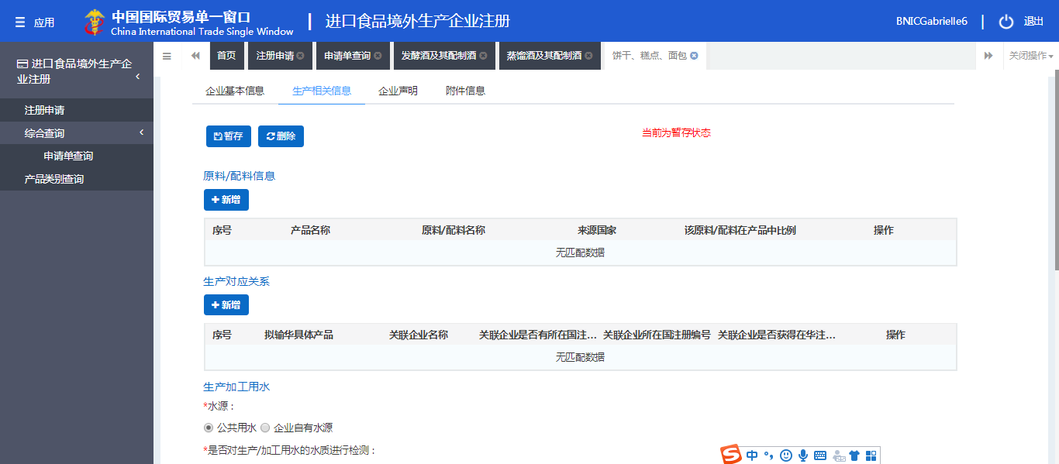

Water for production and processing use

**Add 2**

**Production relationship**

**Add 1**

**Raw material/ingredient information**

**Step 15.**

Click **Add 1** to begin section a): first materials or ingredients in this page.

1. Choose your *Products to be exported to China* by clicking the small button;
2. Click **+ New raw material/ingredient** to provide information accordingly;

Tip: in this step, you can only choose instead of typing your *Country of origin*.

1. Click **Save** to proceed.

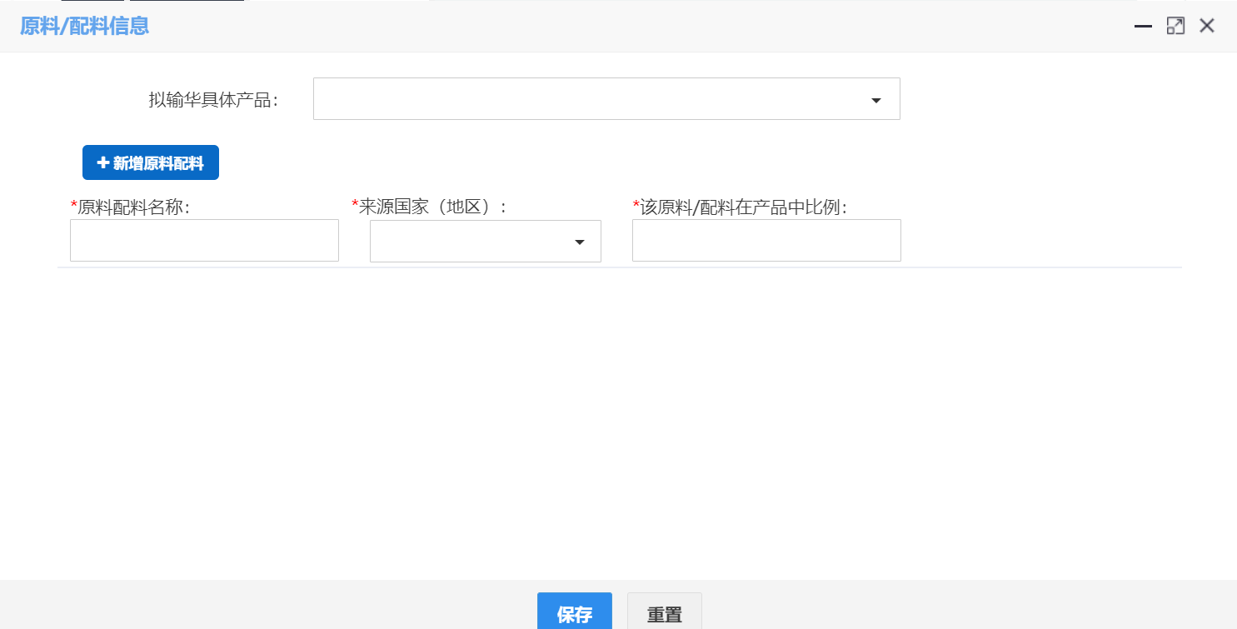

**+ New raw material/ingredient**

Raw material/ingredient name Country of origin Ratio of raw material/ingredient in the product

Products to be exported to China

**Save Reset**

**Raw material/ingredient information**

Move on to section b): This page is to collect the information concerning the affiliated company.

1. Choose *Products to be exported to China* by clicking the small button.
2. Choose or fill in blanks accordingly.
3. Click **Save** to proceed.

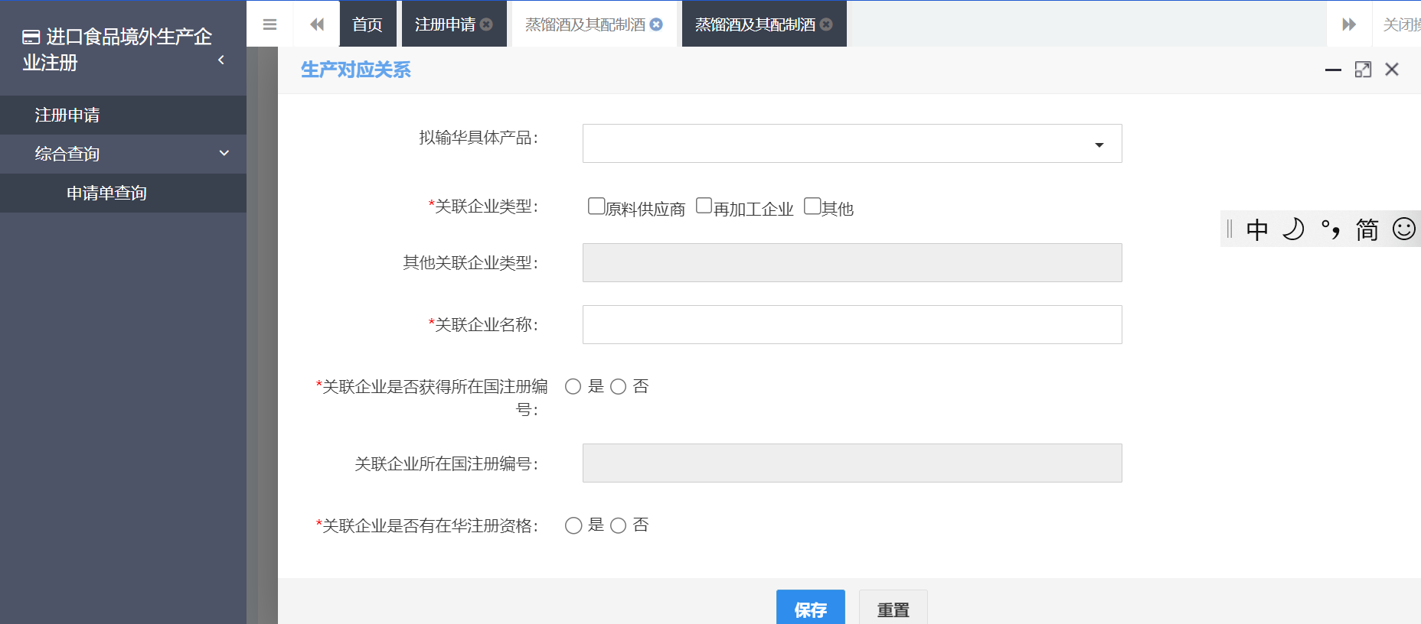

Application file inquiry

Comprehensive inquiry

Affiliated company type: □Raw material supplier □Reprocessing company □Other

Products to be exported to China

Registration number of the country in which the affiliated company is situated

If affiliated company is eligible to be registered in China: □Yes □No

**Save Reset**

Other affiliates type

Affiliated company name

If affiliated company has obtained registration number of the country in which it is situated: □Yes □No

**Production relationship**

**Step 16.**

Roll down the page to begin section c: this page aims at collecting information related to production or processing water.

You simply need to mark your choice accordingly.

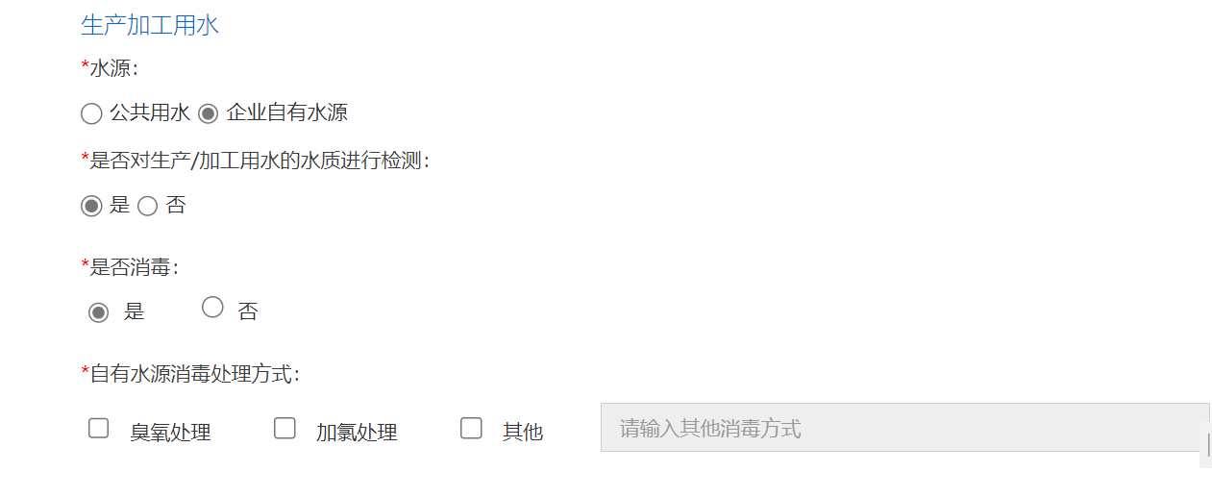

Water for production and processing use

Water resources:

□Public water resources □Company’s own water resources

If the water for production and processing use has been tested

□Yes □No

If the mentioned water has been disinfected

□Yes □No

Disinfection method

□Ozone treatment □Chlorination treatment □Other（Specify）:

For product processing techniques and HR information, roll down the page and continue to answer questions.

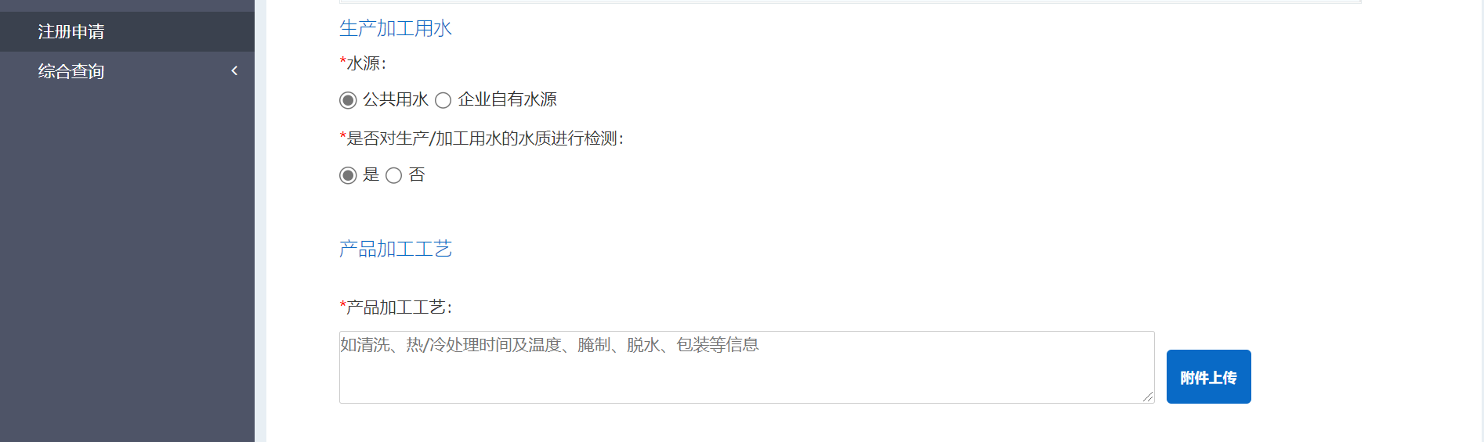

Human resources:

Total number of company employers

Number of management technicians

Water for production and processing use

Water resources:

□Public water resources □Company’s own water resources

If the water for production and processing use has been tested

□Yes □No

Product processing techniques

Provide product processing information:

e.g. cleaning, cold/hot treatment, temperature, pickled, dehydration, package, etc.

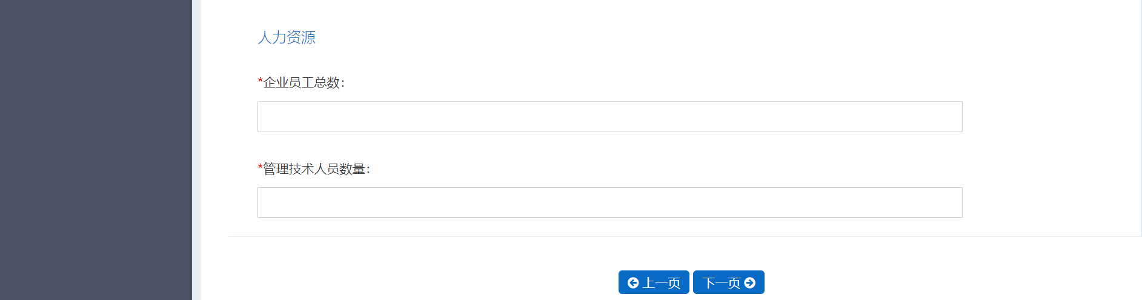

Previous page - Next page

**Step 17.**

This page allows you to attach files specifying the production or processing of your products.

1. Click **+ Upload** to upload files. Here, an example has been done for you. A processing flow has been uploaded, and it is **not the compulsory file**. You can skip this step.
2. Click **Save** to proceed.

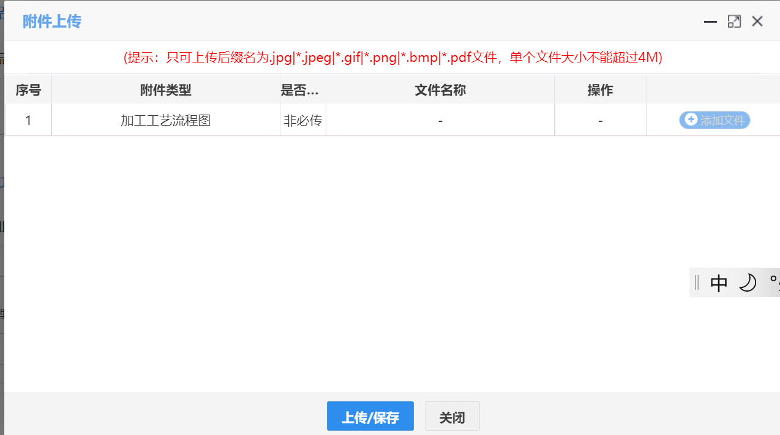

Only accept files in jpg,jpeg,gif, png,bmp,pdf formats, smaller than 4M

**Upload /Save** **Close**

N°, Attached file type, If it is compulsory to upload, File name, Operation, **+ Upload**

**Attach file**

**Step 18.**

These pages give you a general idea (look-back) of the 3 sections mentioned above:

1. When you see on the head of this page Production information becomes blue, it means that you open the right page, and can start provide relevant information.
2. Click **+Add 1** to provide information concerning raw material or ingredient.
3. Click **+Add 2** to provide information concerning affiliated company implied by your products.
4. Then start to answer questions related to Water for production and processing use.
5. Then move on to questions concerning Product processing and Human resources.
6. Click Next page to proceed.

Tip: you can always choose to **Save for now or Delete** the information that you have filled in this page.

For Product processing techniques part:

The blank is limited to 1024 bites. Otherwise you may choose to upload an attachment (not necessary). We suggest you to fill it as simple as possible.

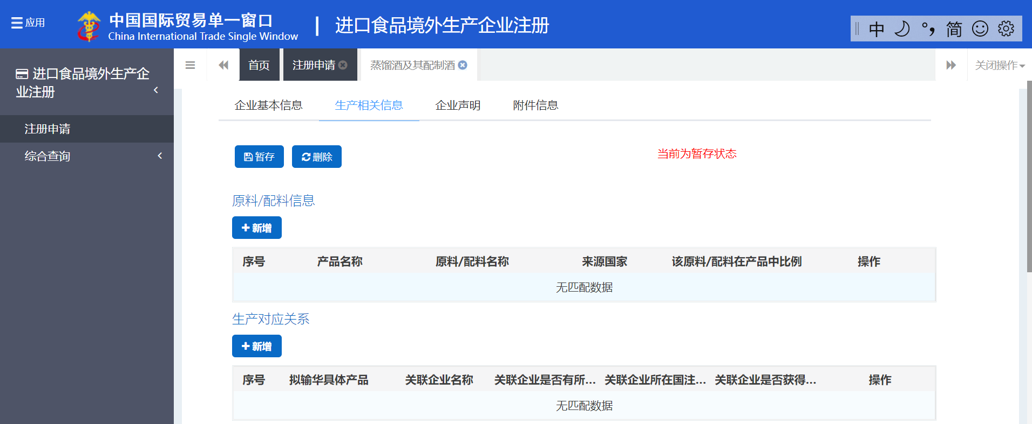

N°, Name of product to be exported to China, Affiliated company name, If affiliated company has obtained registration number of the country in which it is situated, Registration number of the country in which the associated company is situated, If affiliated company is eligible to be registered in China, Operation

Production correspondance

N°, Name of product to be exported to China, Raw material/ingredient name, Country of origin, Ratio of raw material/ingredient in the product, Operation

**+Add 2**

**+Add 1**

Raw material/ingredient information

Current stage : save for now

**Save for now ; Delete**

Basic information of the company, Production information, Company statement, Attachment information



Water for production and processing use

Water resources:

□Public water resources □Company’s own water resources

If the water for production and processing use has been tested

□Yes □No

Product processing techniques

Provide product processing information:

e.g. cleaning, cold/hot treatment, temperature, pickled, dehydration, package, etc.



Previous page - Next page

Human resources:

Total number of company employers

Number of management technicians

**Step 19.**

This page allows you to upload company statement.

1. When you see on the head of this page Company statement becomes blue, it means that you open the right page, and can start providing the requested statement.
2. You need download Company statement.
3. Sign, seal and scan it.
4. Upload the scanned version by clicking **Upload file**.

Tip: you can always choose to **Save for now or Delete** the information that you have filled in this page.

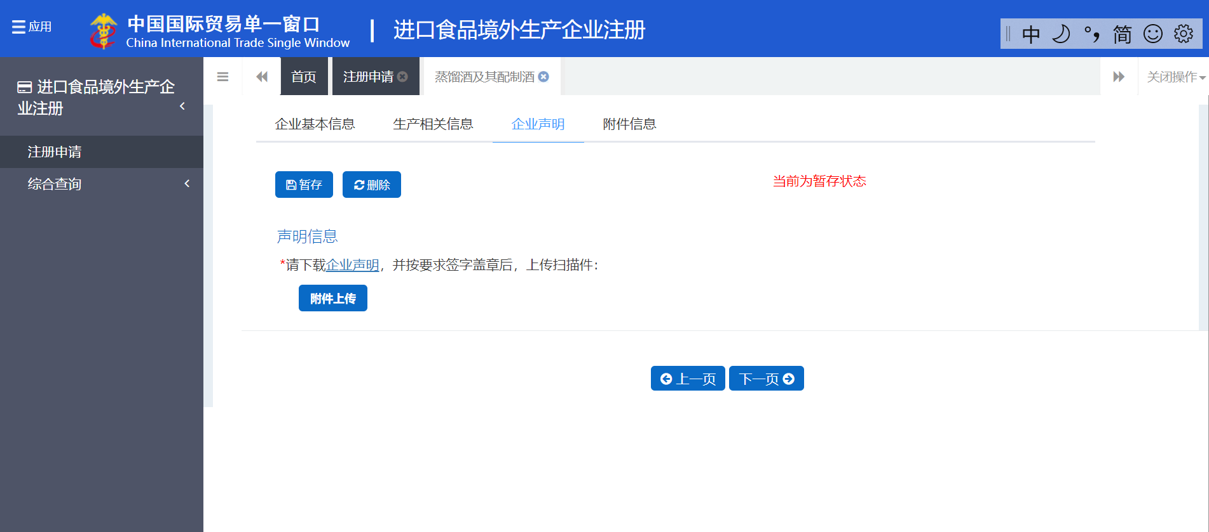

**Save for now ; Delete**

Company statement

Please download Company statement, sign and seal as required, upload the scanned copy

**Upload file**

Previous page Next page

Current stage : save for now

Basic information of the company, Production information, Company statement, Attachment information

**Step 20.**

1). Click **+ Upload** to upload the company statement.

2). Click **Save** or **Close** to proceed.

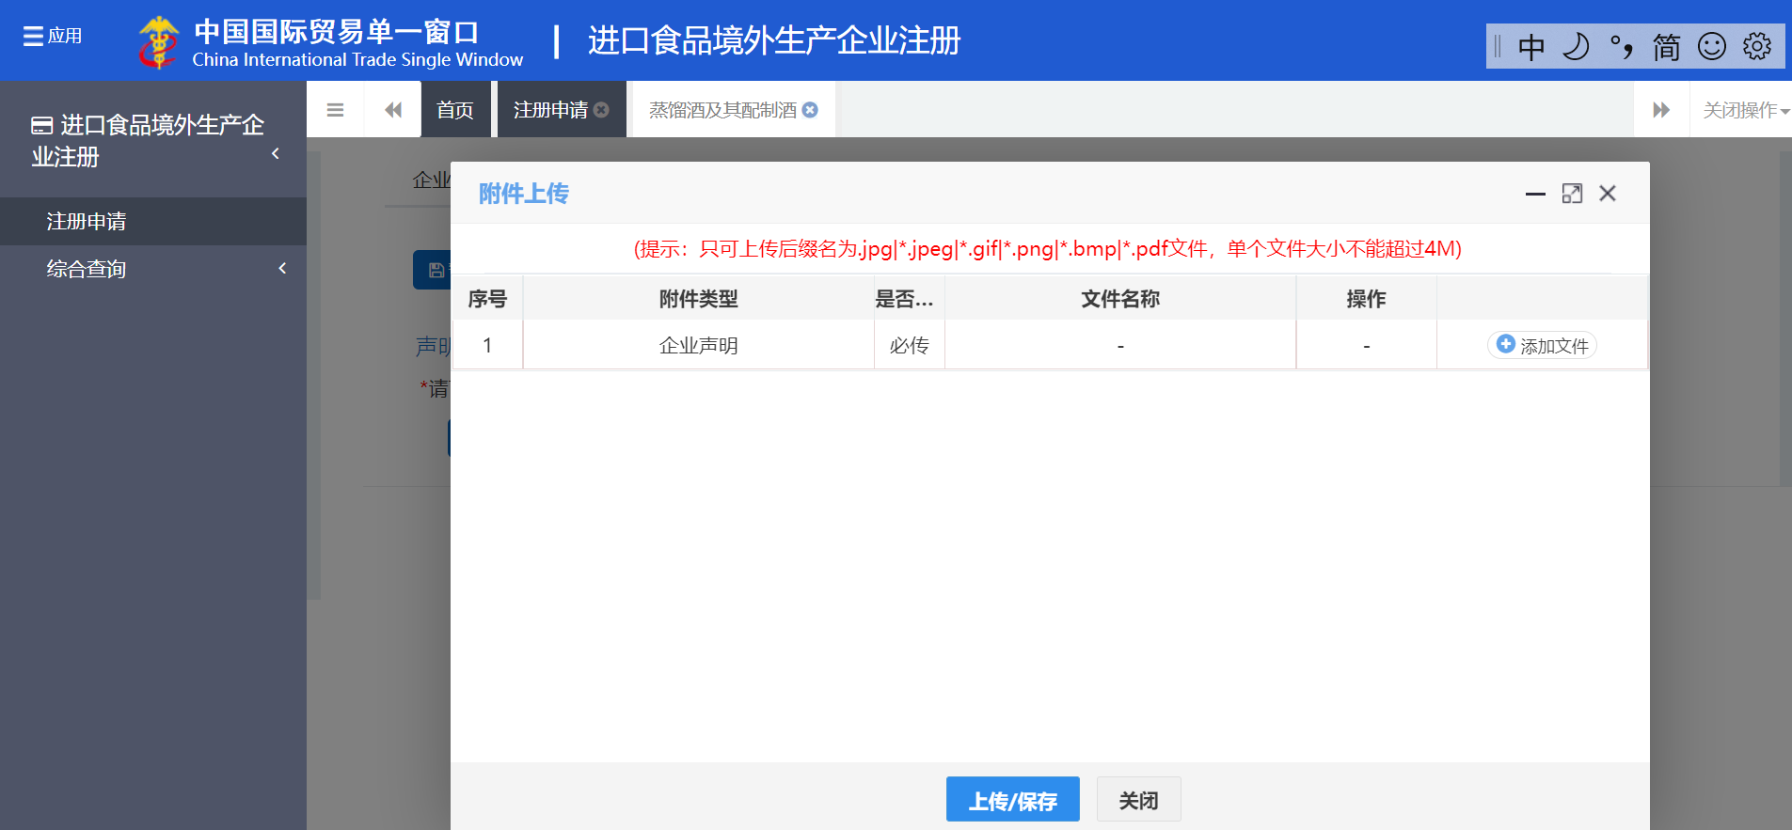

N°, Attached file type, If it is compulsory to upload, File name, Operation,

1 Company Statement Compulsory - - **+ Upload**

**Upload file**

**Upload /Save** **Close**

Only accept files in jpg,jpeg,gif, png,bmp,pdf formats, smaller than 4M

**Step 21.**

This page shows what happens after you upload your company statement.

You can choose to **delete or edit** it, you can also choose to continue to **+ upload** files.

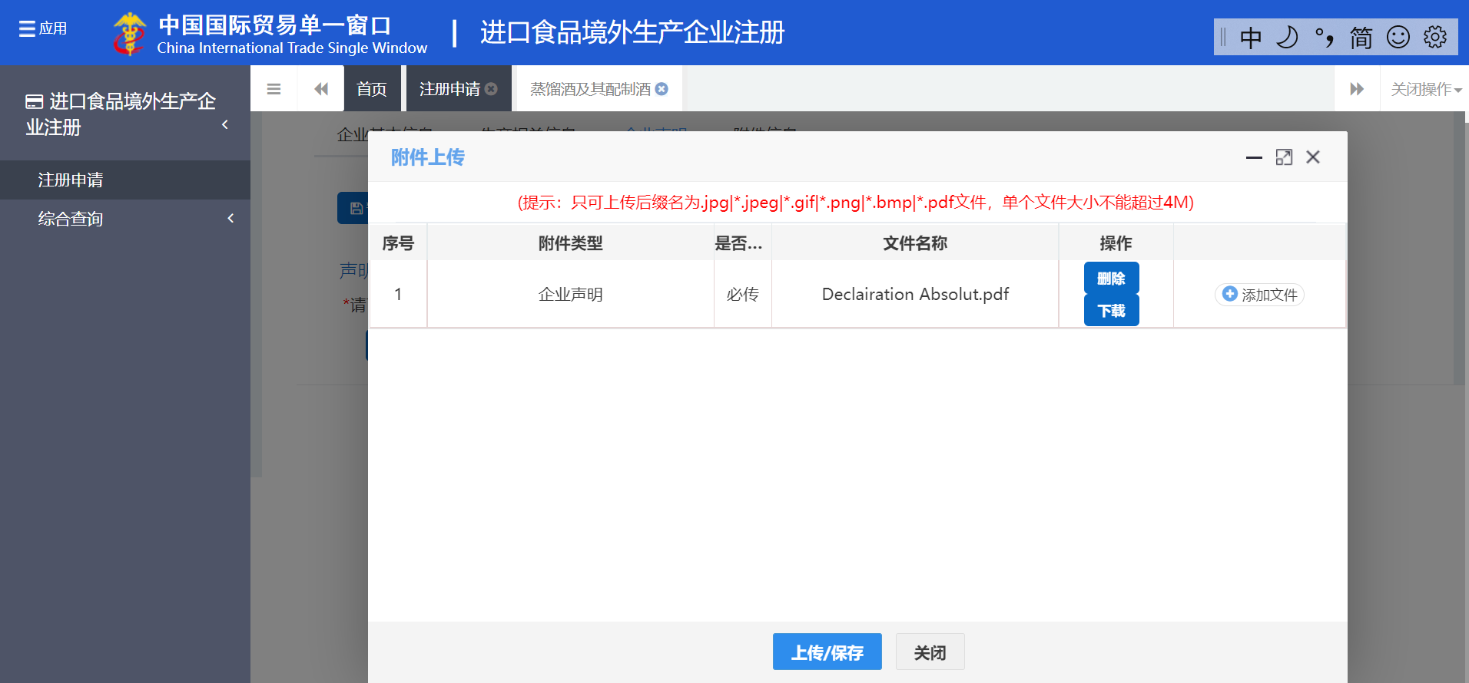

**Upload /Save** **Close**

**Upload file**

Only accept files in jpg,jpeg,gif, png,bmp,pdf formats, smaller than 4M

N°, Attached file type, If it is compulsory to upload, File name, Operation,

1 Company Statement Compulsory - **Delete + Upload**

**Download**

**Step 22.**

This page shows all the files that you have uploaded. You can see their names, choose to **edit**, **delete** or **+** **upload** them.

If there is no problem, clickPreview.

Tip: you can always choose to **Save for now or Delete** the information that you have filled in this page.

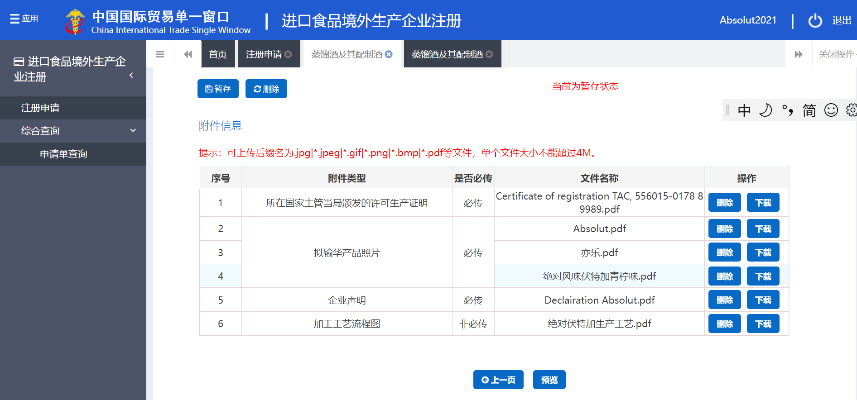

Comprehensive Inquiry

Attached file information

Previous page Preview

Current stage : save for now

**Save for now ; Delete**

Application file inquiry

Only accept files in jpg,jpeg,gif, png,bmp,pdf formats, smaller than 4M

N°, Attached file type, If it is compulsory to upload, File name, Operation,

1 Company Statement Compulsory - **Delete**

**Download**

**Step 23.**

This page allows you to view all the files which you have uploaded for application. They are:

* Production permission granted by the competent authority of the country where is situated your company.
* Photos of products to be exported to China.
* Company statement.
* Production/Processing flow (optional).

You can choose to **Delete** or **Download** them by clicking the blue button.

Finally, you can click **Declaration** or **Return**.

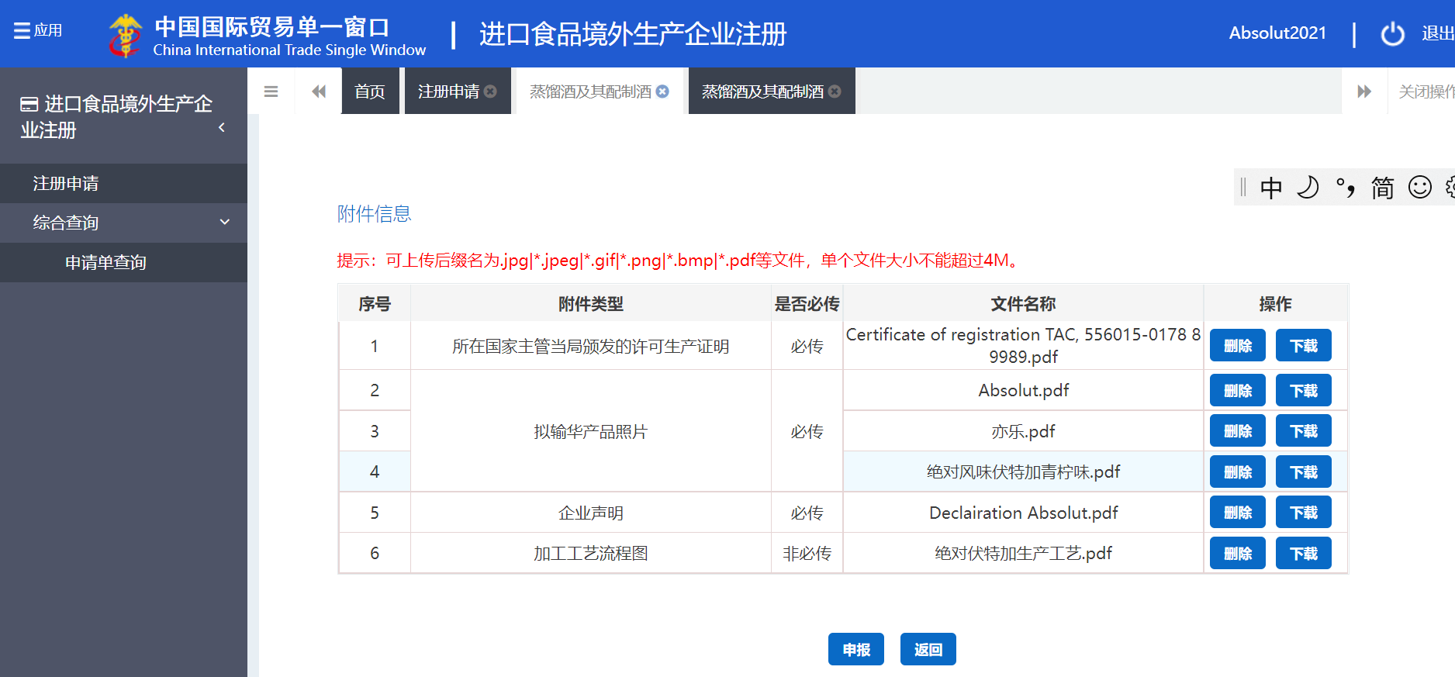

N°, Attached file type, If it is compulsory to upload, File name, Operation,

1 one of the four files mentioned above, Compulsory, - **Delete**

**Download**

Comprehensive Inquiry

Only accept files in jpg,jpeg,gif, png,bmp,pdf formats, smaller than 4M

**Declaration Return**

Application file inquiry

Attached file information

|  |  |  |  |  |
| --- | --- | --- | --- | --- |
| N° | Attached file type | If it is compulsory to upload | File name | Operation |
| 1 | Production permission granted by the competent authority of the country where is situated your company | Compulsory | Certification of registration XXX | Delete Download |
| 2 | Photos of products to be exported to China | Compulsory | Absolut | Delete Download |
| 3 | Yile | Delete Download |
| 4 | Absolute Vodka lime-flavored | Delete Download |
| 5 | Company statement | Compulsory | Declaration Absolut | Delete Download |
| 6 | Production/Processing flow | Optional | Absolute Vodka Processing Flow | Delete Download |

**Annexes:**

1. ***GACC CIFER registration guide***



1. ***HS codes list provided by GACC*** *(Chinese version)*



1. ***HS codes list provided by GACC*** *(English version)*



1. ***The list of products / HS codes submitted to registration or self-declaration:***

[中国国际贸易单一窗口 (singlewindow.cn)](https://cifer.singlewindow.cn/deskserver/sw/deskIndex?menu_id=cifer001)

Step a:

Click the link above to open single window, then log in as instructed at the beginning of this guidance book.

Step b:

Click *Product category inquiry* on the 3rd line of grey section (left side of this page).

Registration Declaration

Inquiry

Product category inquiry

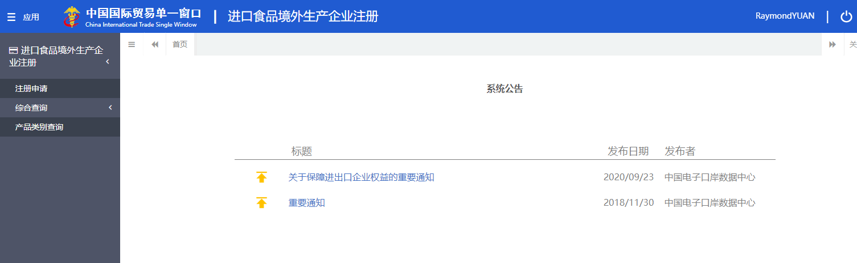

Step c:

Insert relevant HS code, then start verification:

If in the results the last column is 是, validation of the competent authority of the exporting country is needed.

Selection criteria

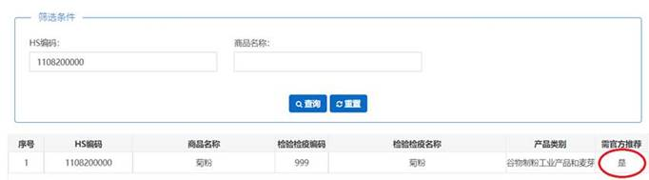

**Inquiry Reset**

Product name

HS code

N° HS code Product name IQ code IQ name Product category If official recommendation is needed

IQ: inspection and quarantine

If it is written 否, the second last column tells you under which category it falls in the platform:

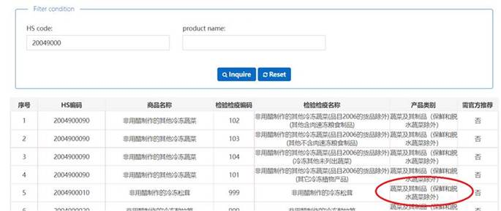

N° HS code Product name IQ code IQ name Product category If official recommendation is needed

**If there is no result**, it means this HS code is not applicable to Decree 248.

For example, HS code for French fries:

Selection criteria

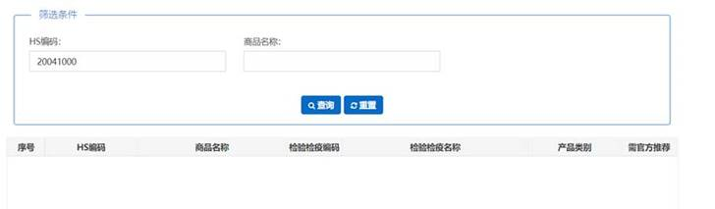

N° HS code Product name IQ code IQ name Product category If official recommendation is needed

**Inquiry Reset**

Product name

HS code

Question: French fries are foodstuff so why are they not under decree 248?

Answer by GACC:

Potatoes and potatoes products such as French fries and potato chips are the responsibility of the department of Animal and plant administration of GACC and are currently not subject to decree 248. OK IF the department of animal and plant administration, the bureau of import and export food safety adjustments related to the scope of product management, in accordance with the latest update of the HS code range implementation.

**Conclusion:**

**是: to be registered by authorities (in the list before 30/11)**

**否: to self-registration by operator in** <https://cifer.singlewindow.cn>

**Nothing: not under decree 248**

1. ***Major procedure for self-registration by establishment of food production to be exported to China***

Is the applicant qualified to file an application for obtaining administrative license granted by GACC

是否具备海关行政许可申请资格

File an application

提出申请

Are application files complete and in the right form

材料是否齐全且符合法定形式

Examination of files by GACC

海关审核

Application accepted

予以受理

Are application files complete and in the right form (Yes)

材料是否齐全且符合法定形式

Complete files

补正材料

Inform the applicant of materials he needs completing at one time

一次性告知申请人需要补正的材料

✓

Licence denied

不予许可

License granted

准予许可

If all conditions and criteria are met

是否符合法定条件及标准

🗶

Acceptance denied

不予受理

After correction, application files remain incomplete or in the wrong form

经补正后材料仍不齐全或不符合法定形式

🗶

✓

🗶